**Do the below programs in Arrow function**

## a)Print odd numbers in an array

let numbers = [66,22,65,79,90];

let odd = (number)=>

{

let oddNumbers = [];

for(let index=0;index<number.length;index++)

{

if(number[index] %2 == 0)

{

oddNumbers.push(number[index]);

}

}

console.log(oddNumbers);

}

odd(numbers);

Output:

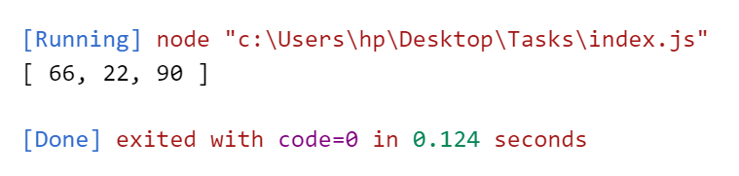

## b)Convert all the strings into a title caps in an array

let strings = ['apple','mangao','grapes'];

let cap = (values)=>

{

let finalArray = [];

for(let string of values)

{

let letter = string.charAt(0).toUpperCase() + string.substring(1);

finalArray.push(letter);

}

console.log(finalArray);

}

cap(strings)

Output:

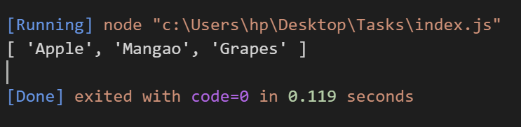

## c)Sum of all numbers in an array:

let numbers = [1,2,4,5];

let sum =(values)=>

{

let result = 0;

for(let index in numbers)

{

result+=values[index];

}

return result;

}

console.log(sum(numbers));

Output:

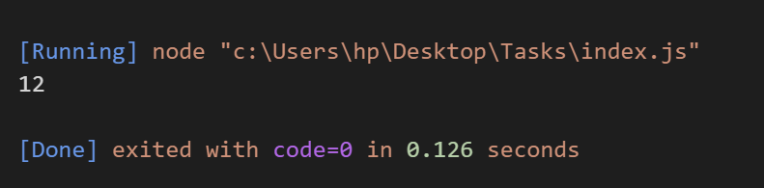

## d)Return all prime numbers in an array.

let numbers = [12,13,14,17];

let prime =(values)=>

{

let isPrime =[];

for(let num of numbers)

{

let factor = 0;

for(let x=0;x<=num;x++)

{

if(num%x == 0)

{

factor++

}

}

if(factor == 2)

{

isPrime.push(num);

}

}

return isPrime;

}

console.log(prime(numbers));

Output:

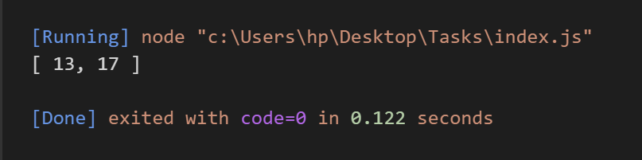

## e)Return all palindrome in an array

let array = ['malayalam','hello','madam'];

let palindrome =(values)=>

{

let palinArray =[];

for(let string of values)

{

let arrayValues = string.split('');

let arrayRev = arrayValues.reverse().join('');

if(string == arrayRev)

{

palinArray.push(string);

}

}

return palinArray;

}

console.log(palindrome(array));

Output:



 